**VPC Peering between 2 different VPC's.**

**VPC:01**

**10.100.0.0/16 --VPC**

10.100.0.0/24--Public Subnet A ( EC2-A-Public)

10.100.1.0/24 --Private Subnet A(EC2-A-Private)

IGW--Public subnet association

**VPC:02**

**192.168.0.0/16 --VPC**

192.168.1.0/24 --Private Subnet B(EC2-B-Private)

Note :Allow only specific subnet **(10.100.1.0/24) to 192.168.1.0/24**

same as **192.168.1.0/24 to 10.100.1.0/24** in the VPC peering section...

in the route table both sides.

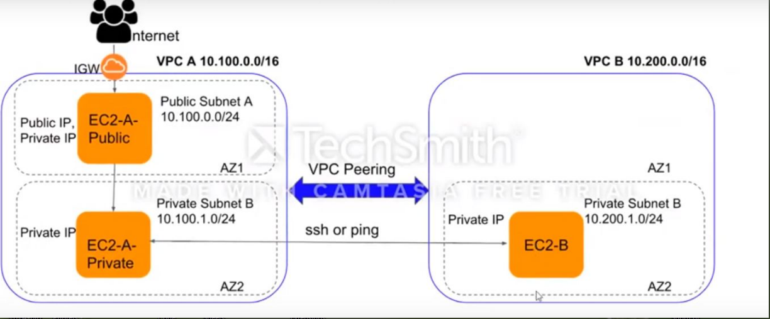Create a VPC-A: **192.168.0.0/16**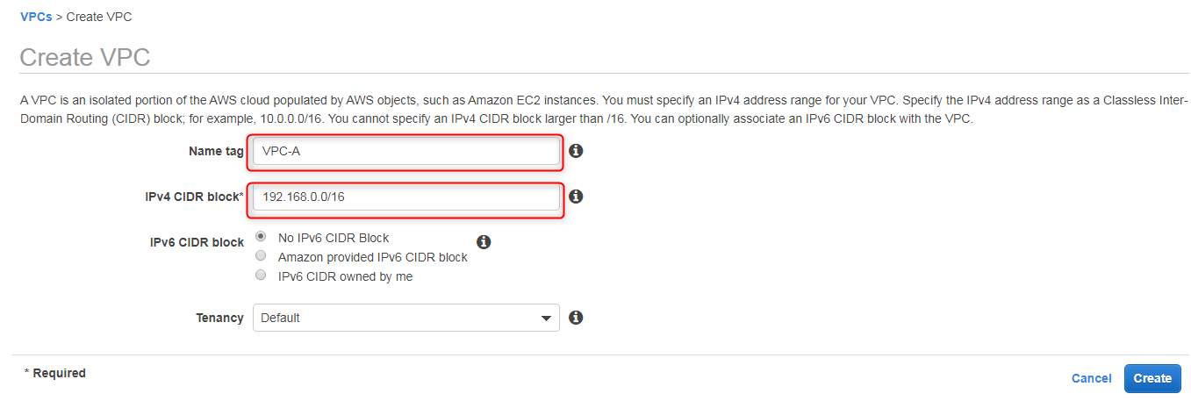

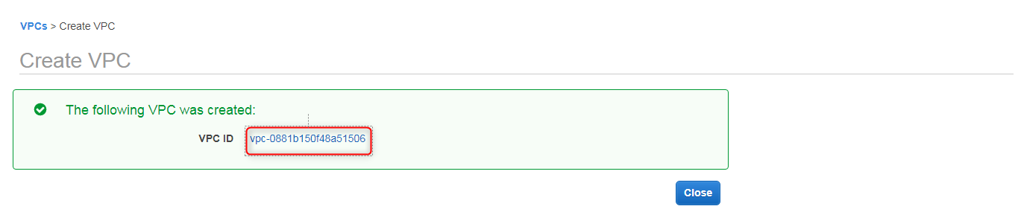

Create a second VPC: **10.0.0.0/16**

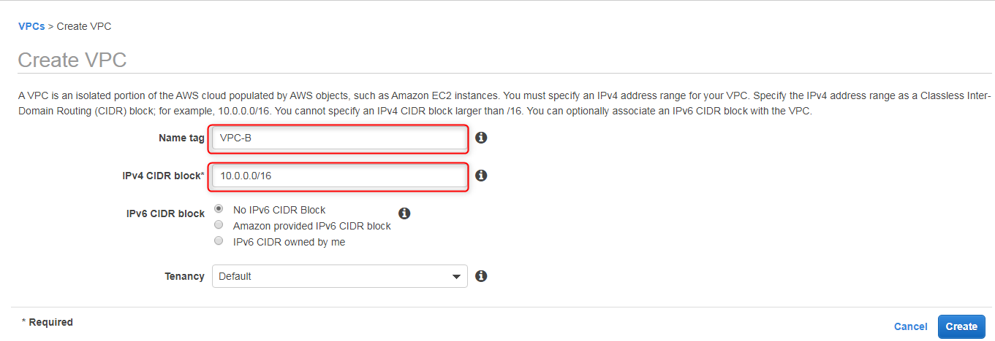

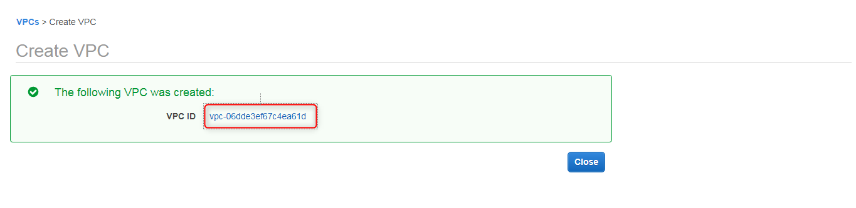

We have created two vpc's. Now we have to create 3 subnets two for VPC-A and 1for VPC-B.

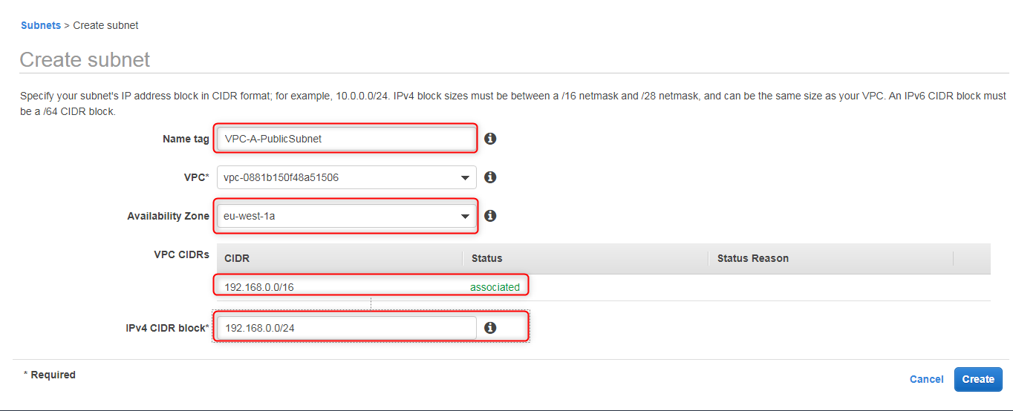



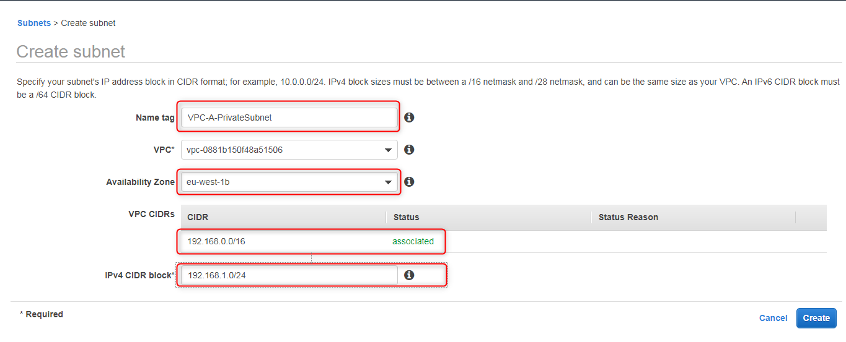





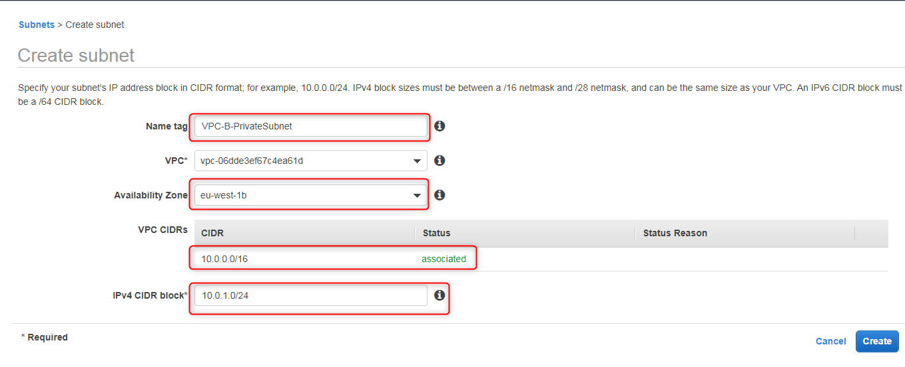



Route table creation:

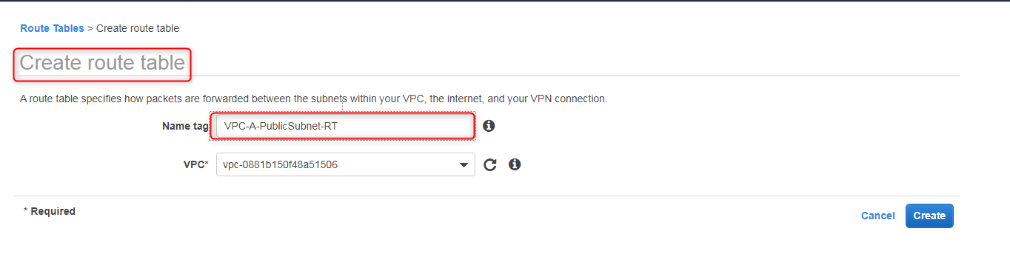

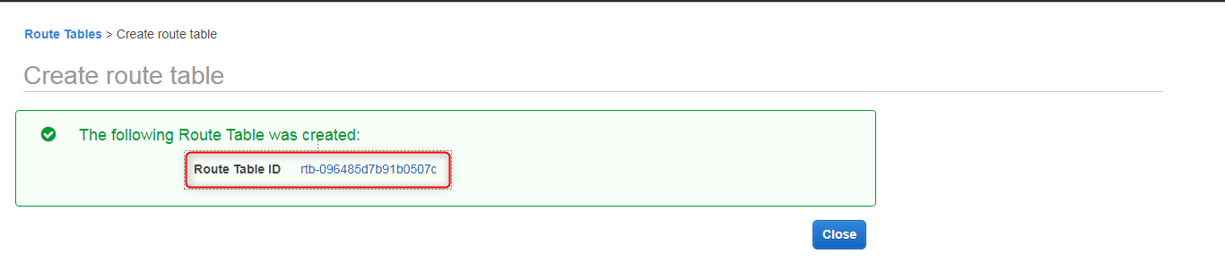

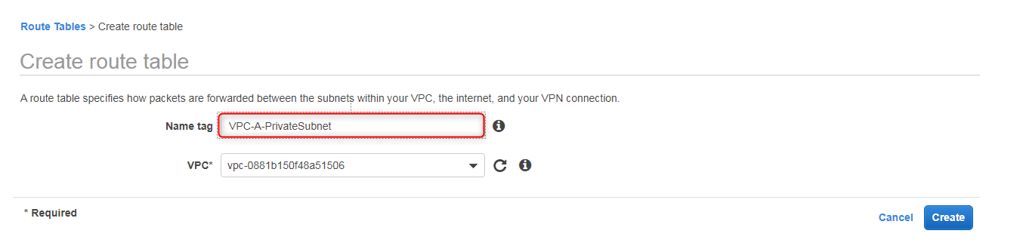

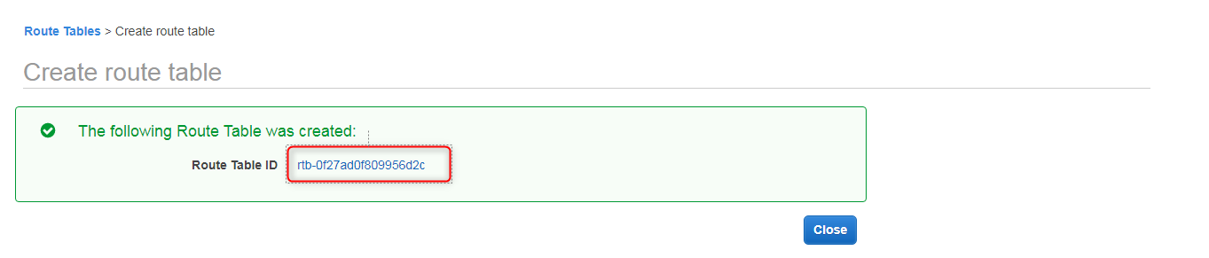



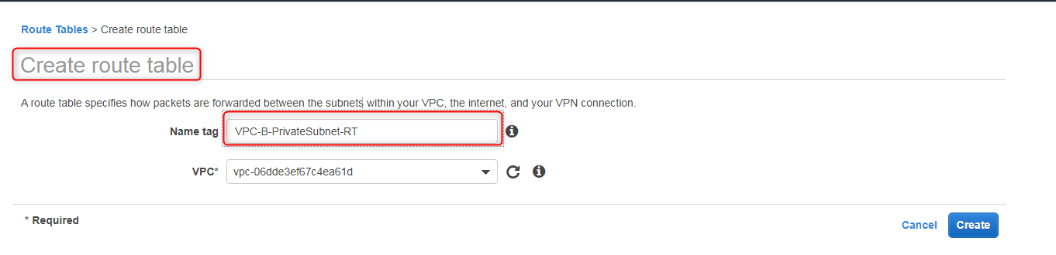

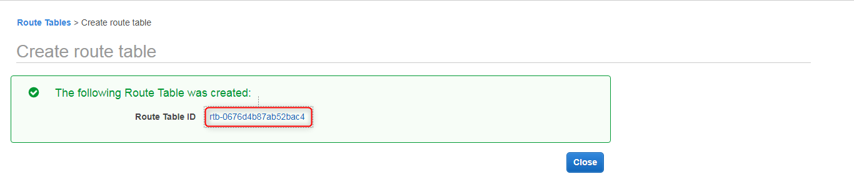

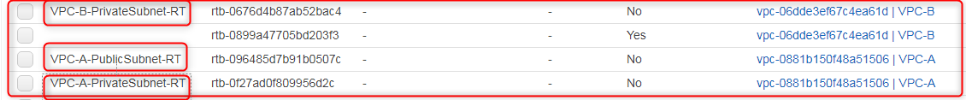

Next we have to create a peering connections between the two vpc's ( 192.168.0.0/16 to 10.0.0.0/16)

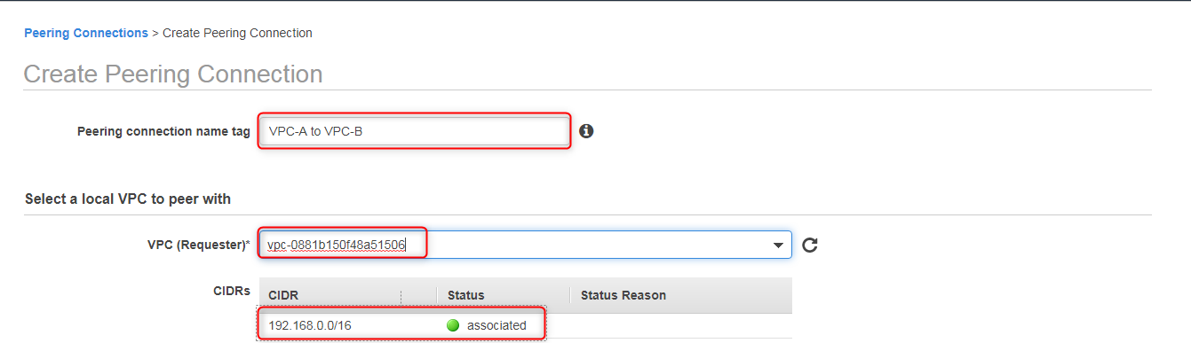

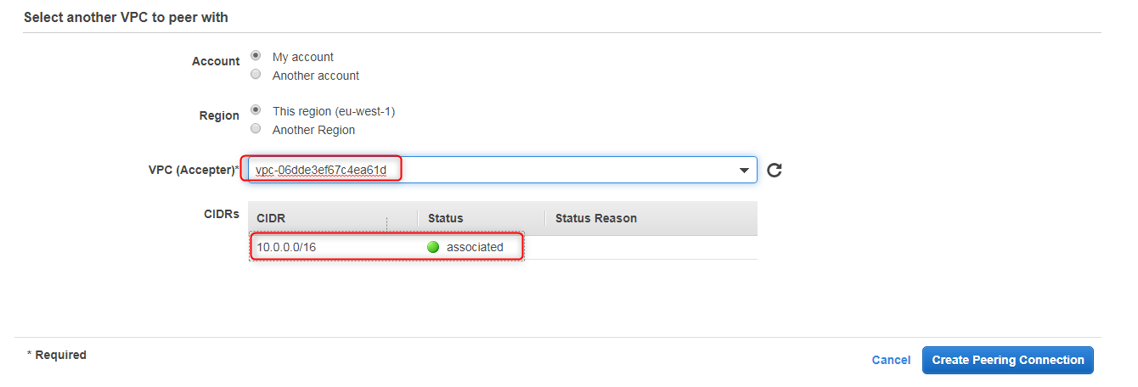

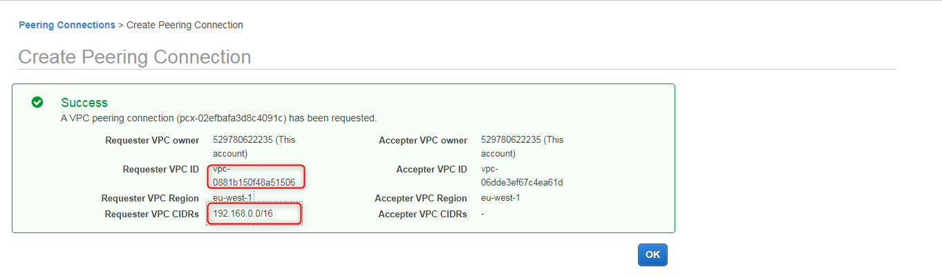

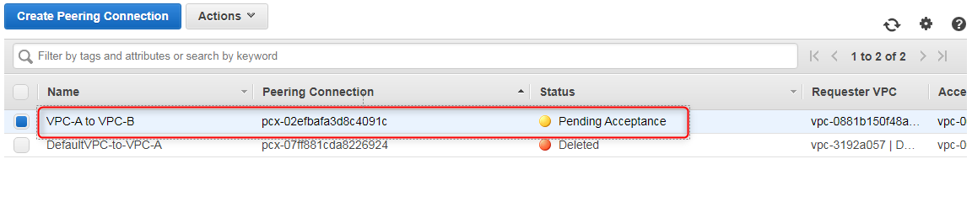

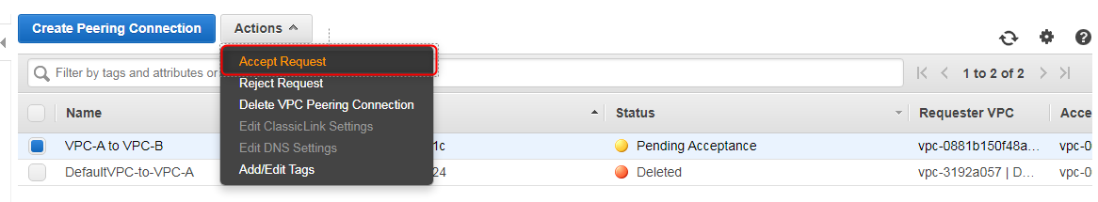

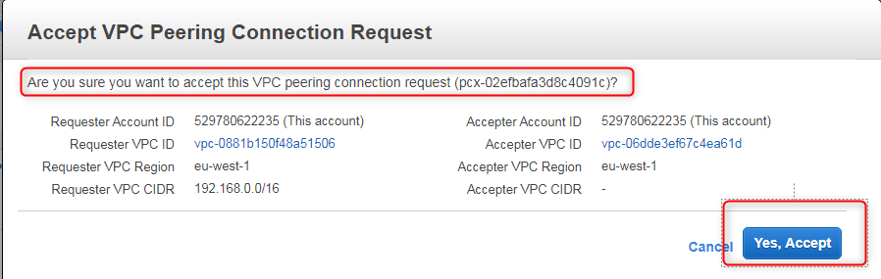

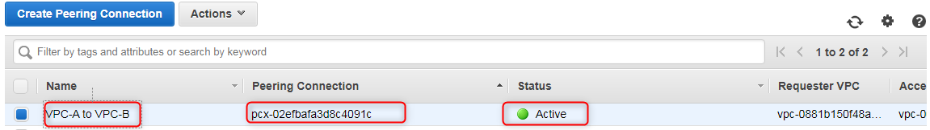

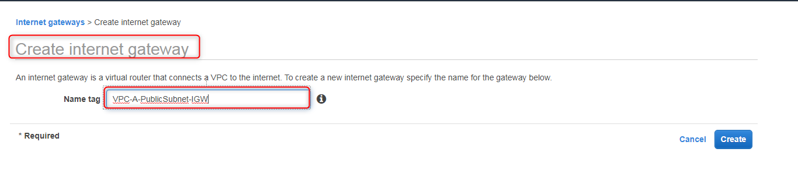



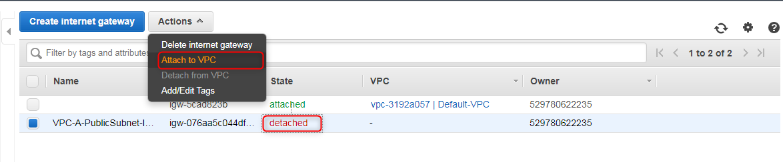

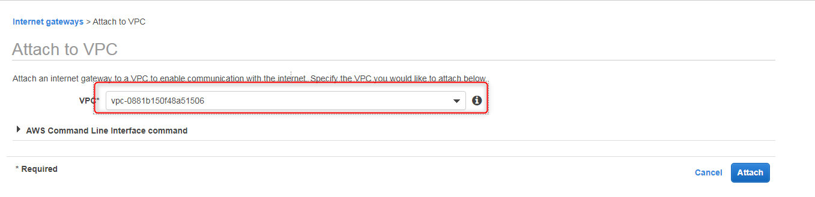

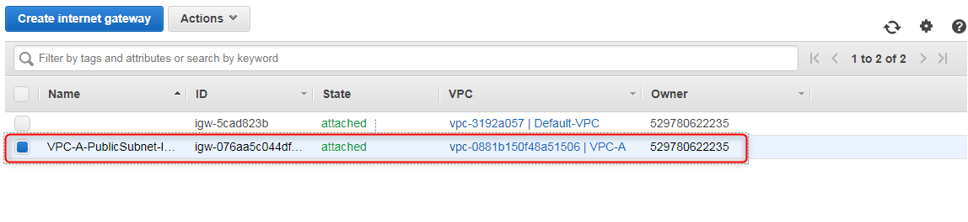

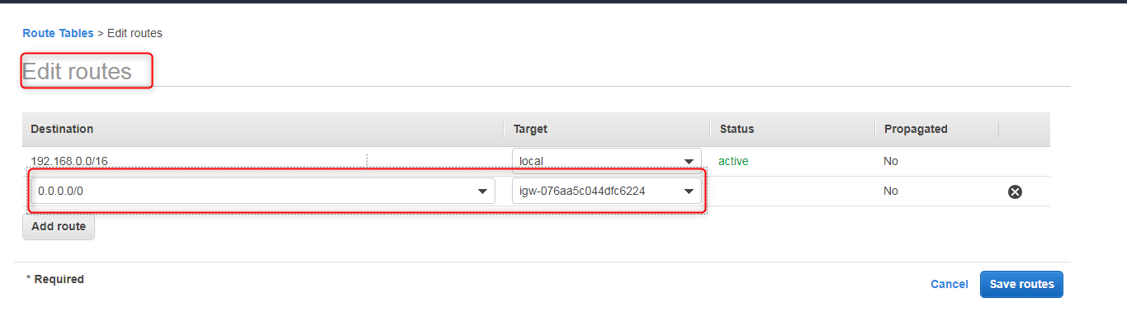

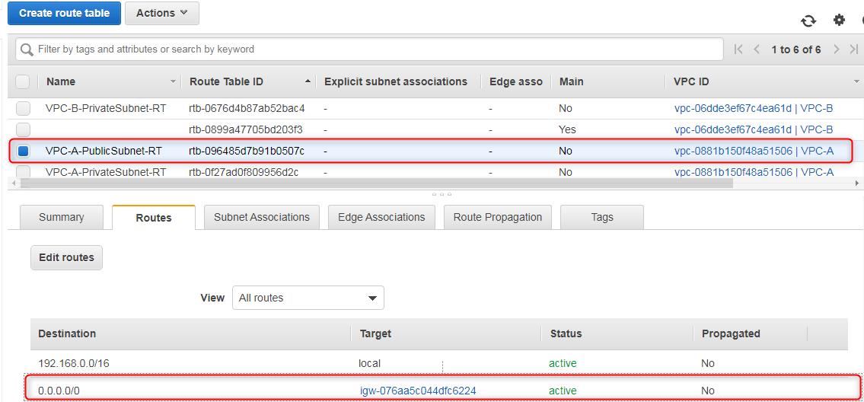

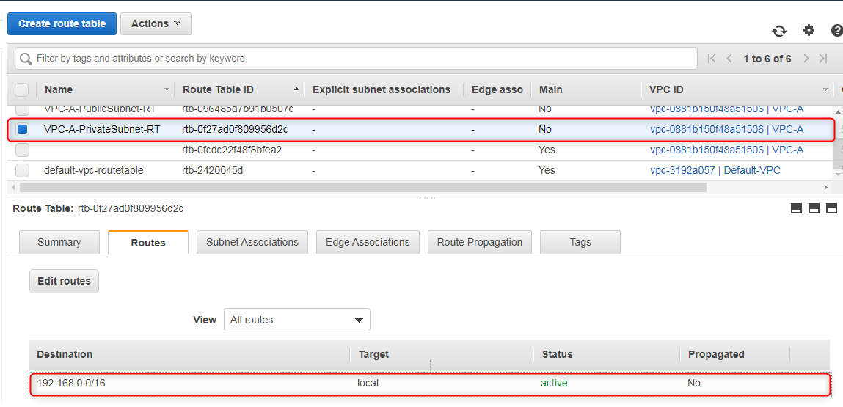

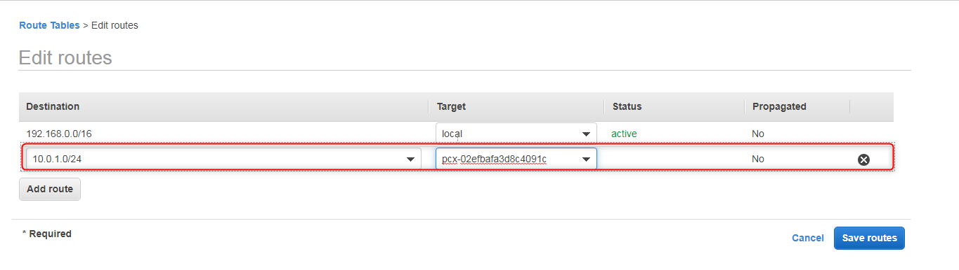

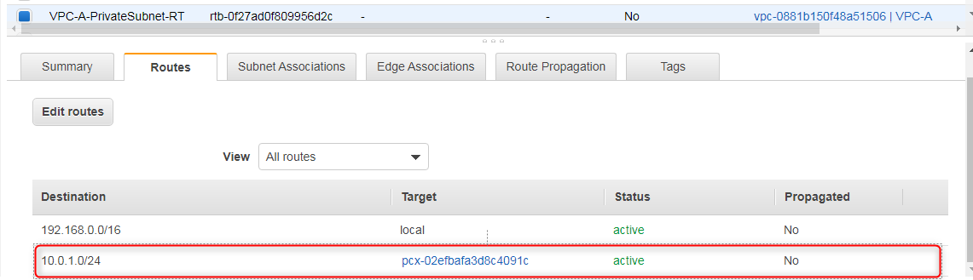

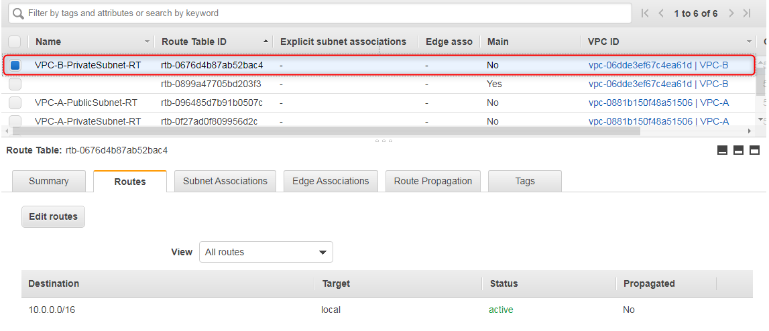

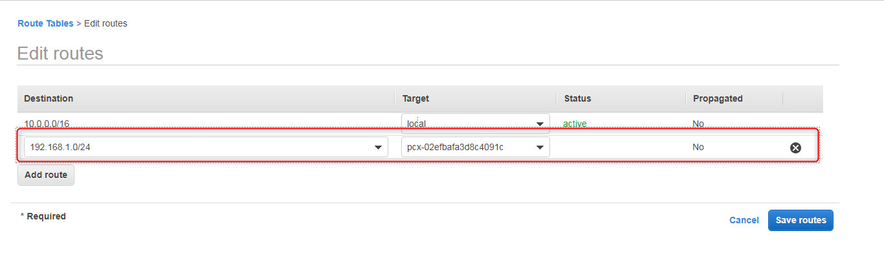

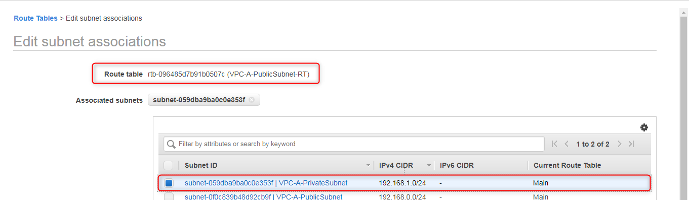

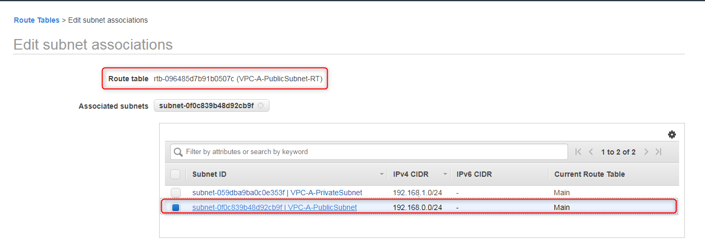

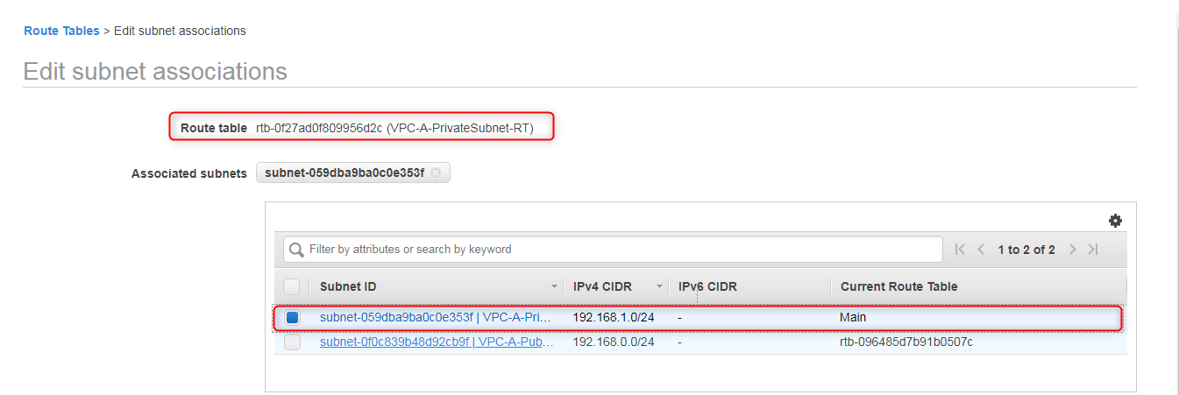

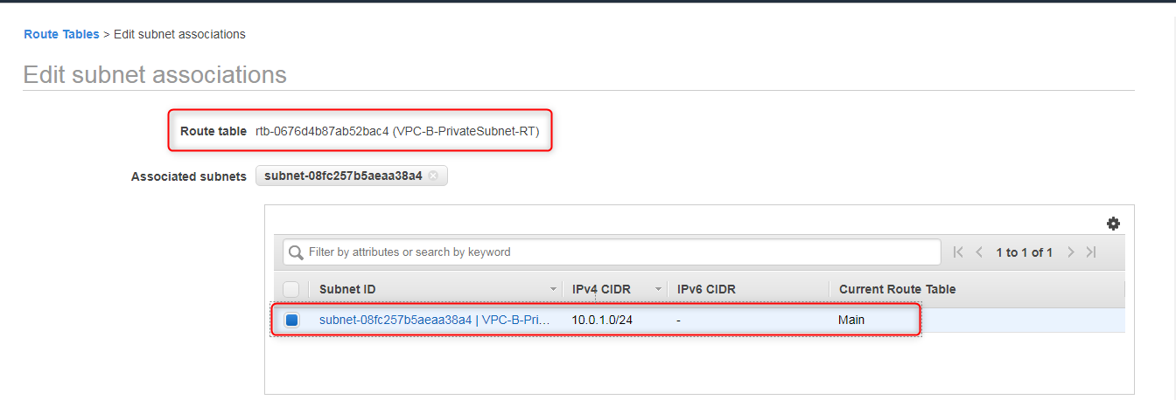

Launch the EC2 instance in Public subnet as given below,

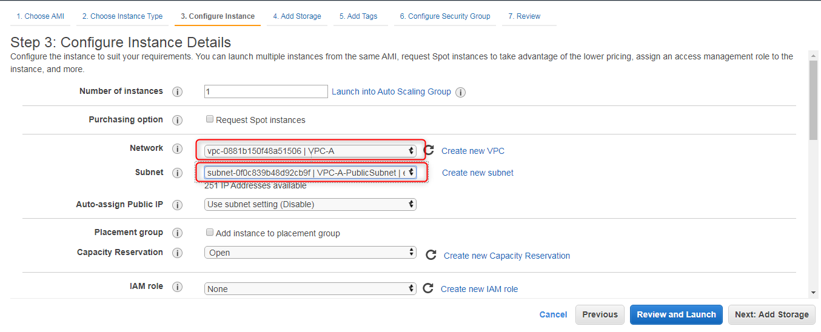

Created an EC2 instance in the Private subnet as given below,

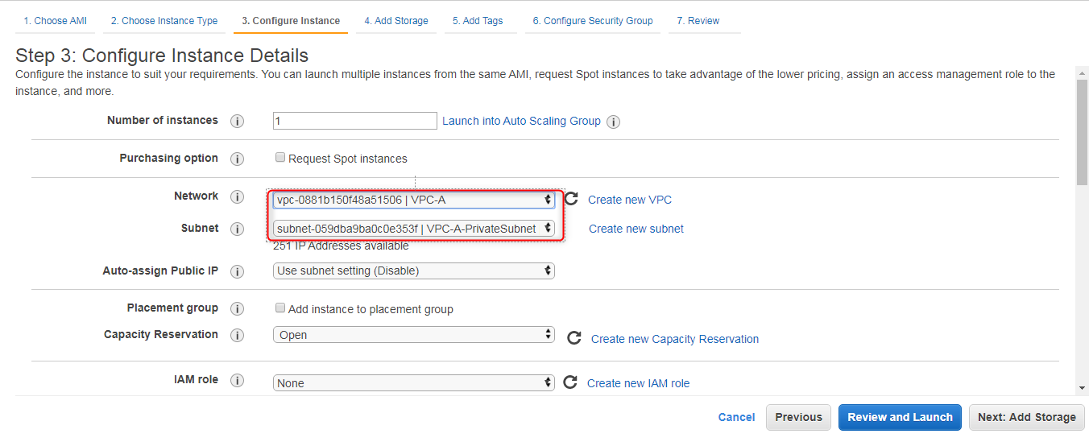

Again created one more EC2 instance in the Second VPC's private network

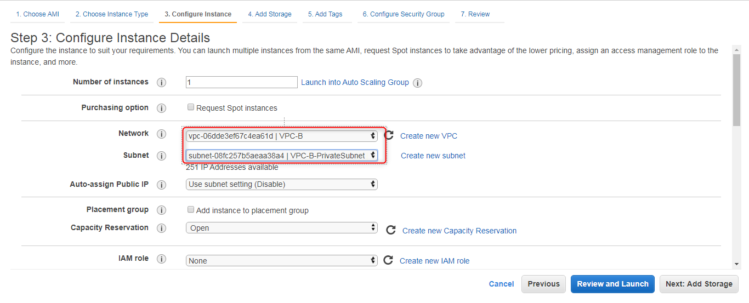

Launched the 3 EC2 instance's are the respective subnets as given below,

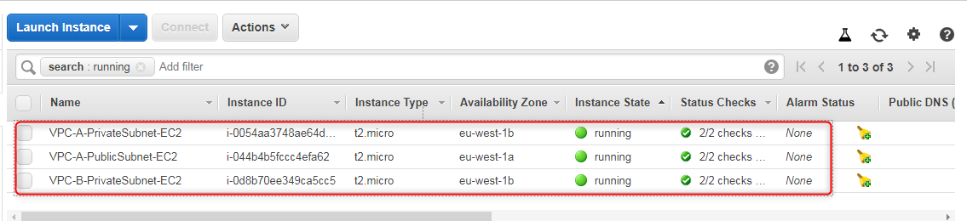

VPC-A >> Public Subnet EC2 instance assigned one EIP for connecting the instance publicly using putty

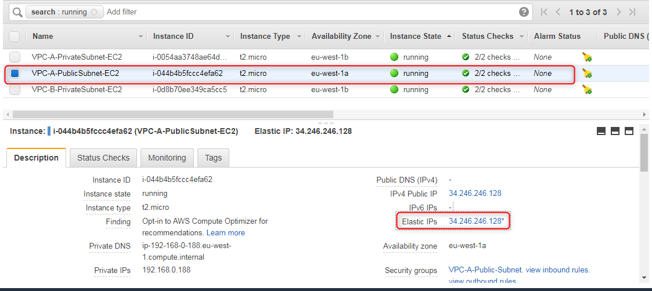

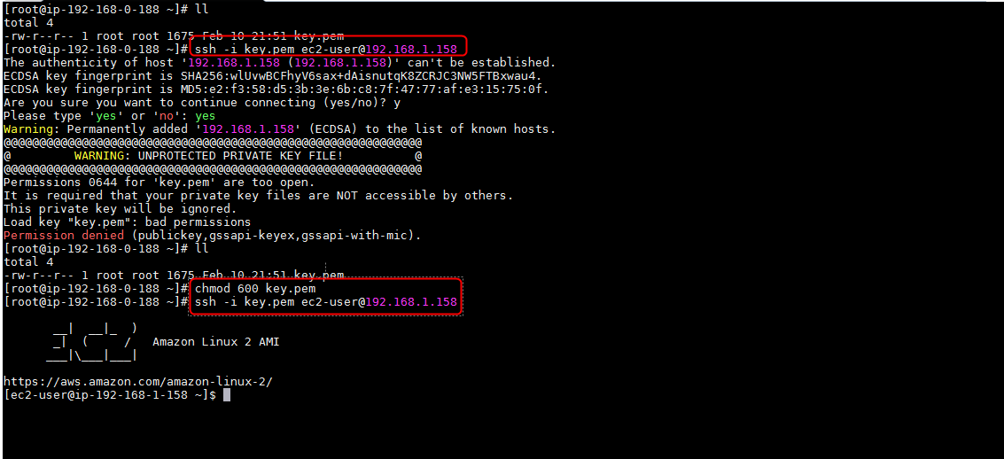

For the .pem key file you have to provide only **600** permission not more than that otherwise you can't connect the ec2 instance.

Next we have to connect the VPC-B Private subnet EC2 instance , just ping the instance using the private ip of the instance as given below, So you will get the response from VPC-A Private Subnet EC2 instance to VPC-B Private subnet EC2 instance. Happy VPC Peering..............:)

